Hello,

I am not sure if this journal requires code to submit. You can find the code used to make the maps at

<https://github.com/jacobgellman/grassland_afforestation>.

I also redid the maps to look nicer. If you would like to download them directly you can access them at

<https://www.dropbox.com/sh/8y8gyubwcln6uia/AAA_d1YU2dXN_1p6AmE6iIUNa?dl=0>.

Must do to submit

1. Maps

The maps I made at those links are much nicer.

Also, the legend

2. Acreage figures.

The 118.4 million acres figure comes from Nielsen et al. (2014), reproduced below.

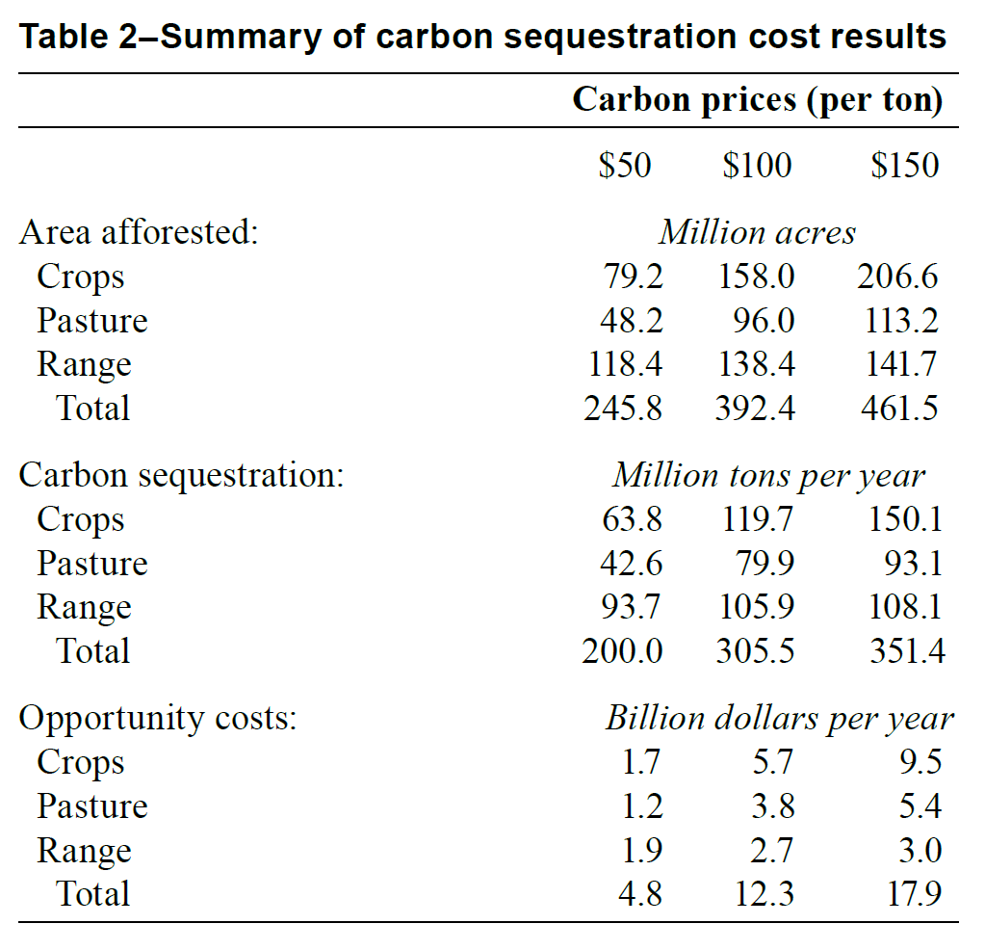

The acreage numbers there do not correspond completely to the analysis I did for the maps.

(a) The acreage numbers in Neilsen et al. (2014) are based on a carbon price in 1997 dollar terms. For this analysis I inflated the dollars to 2007 dollars to be in line with some recent work, i.e. the [California 2017 Climate Change Scoping Plan](https://ww3.arb.ca.gov/cc/scopingplan/scoping_plan_2017.pdf) (see page 62). The inflated dollar terms lead to different results.

(b) The 118.4 figure assumes timber harvesting. The maps I made assume no timber harvesting, thus giving us lower afforested acres. I cannot find a record in my notes as to why we made this decision.

Here is a summary of the acreage afforested under no timber harvesting and then assuming timber harvesting.

|  |  |  |  |  |
| --- | --- | --- | --- | --- |
|  | No periodic timber harvest | | Periodic timber harvest | |
| Carbon price (2007 dollars) | Range (ac) | Total (ac) | Range (ac) | Total (ac) |
| $50.00 | 61,205,300 | 89,340,970 | 102,746,070 | 191,505,730 |
| $20.00 | 10,350,320 | 13,277,550 | 37,923,990 | 68,167,450 |
| $12.00 | 3,339,800 | 5,627,300 | 17,259,600 | 34,171,910 |

I can easily change the analysis to assume timber harvesting. I can also change the inflation terms if you feel it is necessary. I actually think it would make more sense to use more current dollars than 2007, but Andrew had suggested the 2007 mark based on that California Air Resources Board report.

3. Typos.

(a) Page 2, bullet point 3 should say “services.”

(b) Abstract, line 3 should say “incentivize.”

(c) Abstract, line 4 should read “under a carbon market.”

(d) Abstract re: 118.4 million acres figure, see above comment.

(e) Abstract. It is not correct that 118.4 million acres would be afforested in the Great Plains. The 118.4 million acres figure is for the whole U.S. and it is from the Nielsen et al. article. Based on the analysis I did for the maps the Great Plains would see 36,053,240 acres afforested, assuming no period timber harvesting.

Other comments

1. I feel that the term “unwanted costs” in the title is a normative statement. What about something more neutral such as “unintended costs”?

2. Can we write Jacob Gellman rather than Jacob C. Gellman?